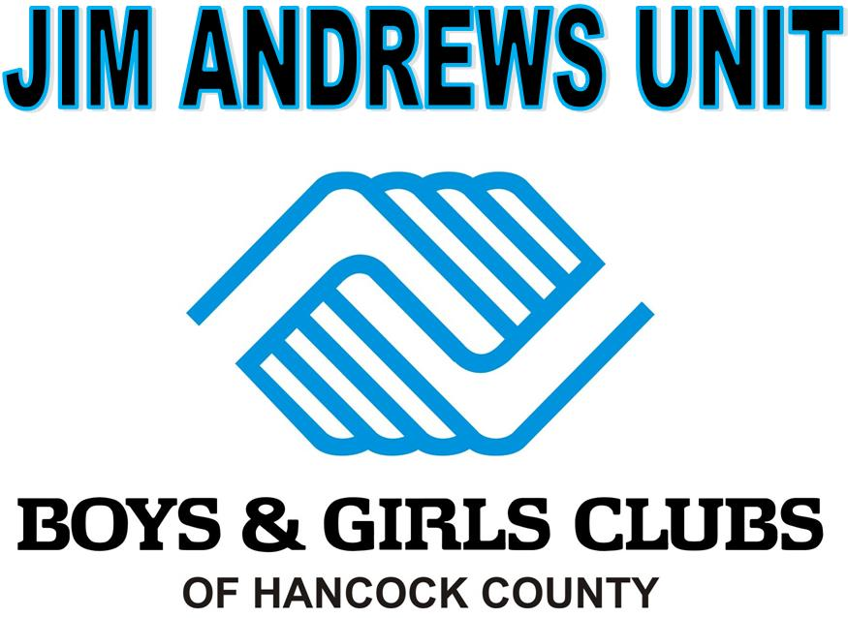
SUMMER PROGRAM
June 11 – July 27, 2018
MONDAY-FRIDAY
7:30am-5:30pm
*$75.00 per week, per child*

(Breakfast, Lunch and a snack provided each day)

Looking for a fun, safe and positive environment for your child(ren) to have fun AND learn all at the same time?
Well, the Jim Andrews Unit is the place to be this summer!
We have a jam-packed schedule of events that will engage your child and keep them wanting to come back for more each day! Whether it is sports or the arts, we have something for everyone!

*Doors will NOT open until 7:30am for drop off and all members must be picked-up by 5:30pm.
(Safe Child Policy will go into effect for late pick-ups!)
* Fees must be paid on the Friday before the attending Session.
* A $5.00 late fee (per child) will be added if not paid on the Friday before the attending Session.

*Members groups based on the grade they will be entering for the 2018-2019 School year**

Member’s Name: ________________________________ Age: _______ Grade in School for 2018-2019:

Member’s Name: ________________________________ Age: _______ Grade in School for 2018-2019:

Member’s Name: ________________________________ Age: _______ Grade in School for 2018-2019:

Member’s Name: ________________________________ Age: _______ Grade in School for 2018-2019:
Parent/Guardian Names:

Phone (H): __________________ (W): ___________________ (C): ___________________

**IN CASE OF EMERGENCY: Name: Phone:

Please circle the Session(s) that your child(ren) will be attending this summer.
If, registering for certain dates, please circle all individual dates your child(ren) will be attending.

**************************Jim Andrews Unit Employees ONLY******************************
Amount Check/ Amount Check/
# Session Dates Paid Cash # Session Dates Paid Cash
*Club is closed June 1 – June 8, 2018* #4 July 2nd-6th (Closed July 4th) ____ ____

#1 June 11th-15th ____ ____ #5 July 9th-13th ____ ____

#2 June 18th-22nd ____ ____ #6 July 16th-20th ____ ____

#3 June 25th-29th ____ ____ #7 July 23rd-27th ____ ____

**PLEASE NOTE: THE JIM ANDREWS UNIT WILL BE CLOSED JULY 30TH-31ST FOR ALL STAFF DEVELOPMENT AND FACILITY MAINTENANCE IN PREPERATION FOR THE UPCOMING SCHOOL YEAR! WE WILL RE-OPEN AUG. 1ST FOR THE 2018-2019 SCHOOL YEAR. IF YOU HAVE ANY QUESTIONS PLEASE CALL 317-462-2404**

