Maxwell Intermediate Literacy Night
and Family “Book Fair” Night
Students that come will get a homework pass!
Play BINGO for BOOKS!
“Saddle Up and Read”
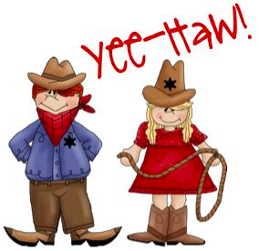

Tuesday, September 19th
6:30 p.m. – 7:30 p.m.
Join us for stations, raffles, & refreshments!

Stations include:
Fun Literacy Games The Book Fair
Win Prizes!!
Tech Time Jumbo Boggle

