2017 POETRY CONTEST HONORING OUR HEROES
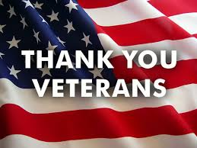

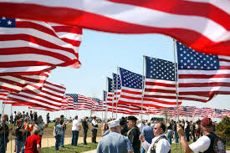
RULES FOR THE POETRY CONTEST ARE AS FOLLOWS:

“ THE POEM MUST BE YOUR ORGINAL WORK ”
TO BE WRITTEN ABOUT A FAMILY MEMBER, FRIEND, OR ANY MILITARY VETERAN YOU FEEL NEEDS TO BE RECOGNIZD FOR THEIR SERVICE IN THE ARMED FORCES.
THEME: MILITARY VETERAN - IT CAN BE ABOUT AN INDIVIDUAL OR A GROUP OF VETERANS
TITLE: YOUR CHOICE
LENGTH: 24 LINES OR LESS
STYLE: RHYMING
SUBMIT: TWO COPIES – ONE WITH YOUR NAME, ADDRESS, PHONE NUMBER. THE OTHER WITH NO IDENTIFCATION. (THE JUDGE(S) WILL ONLY SEE THE COPE WITH NO IDENTIFICATION TO MAKE IT FAIR)

TWO CATEGORIES:
6-7-8 GRADES IN HANCOCK COUNTY
3-4-5 GRADES IN HANCOCK COUNTY
PRIZES FOR EACH CATEGORY:
FIRST PLACE: $50.00 – CERFIFICATE – RIBBON
SECOND PLACE: $25.00 – CERTIFICATE – RIBBON
THIRD PLACE: $15.00 – CERTIFICATE - RIBBON
1ST HONORABLE MENTION - CERTIFICATE - RIBBON
2ND HONORABLE MENTION - CERTIFICATE - RIBBON
3RD HONORABLE MENTION - CERTIFICATE - RIBBON

POEMS NEED TO BE SUMITTTED TO YOUR TEACHER BY SEPTEMBER 11, 2017 OR MAILED TO LARRY HUSTON AT 5903 W. COUNTRYSIDE DRIVE NEW PALESTINE, IN. 46163

WINNERS WILL BE INVITED TO ATTEND AN AWARD CEREMONY AT AMERICAN LEGON POST 182 “GUESTS OF WINNERS ARE VERY WELCOME TO ATTEND”

1ST, 2ND, & 3RD PLACE WINNERS WILL BE INVITED TO READ YOUR WINNING POEMS AT AN AWARD CERMONY.

WHERE: AMERICAN LEGION POST 182 MEETING
WHEN: APPROX. LATE SEPTEMBER?

