2017 Young Filmmakers and Animators Workshops
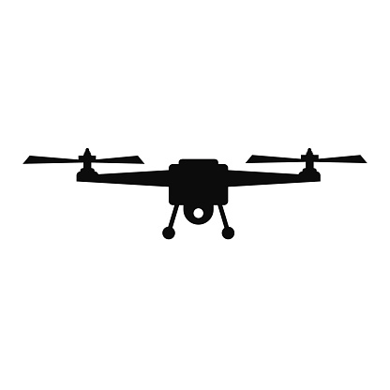
Mt. Vernon High School is offering summer workshops for 10-14 year olds interested in filmmaking and animation. Students learn the basics of computer modeling, texturing, lighting, and animation using Maya and 3ds Max. 3D scanning and digital audio production are also introduced. Students also learn how to record and edit video in a working studio. New this year is a digital sculpting station and a Phantom 4 drone that records 4K video!
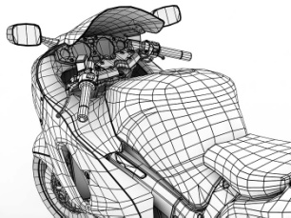

Cost for the workshop is $60 (includes daily snacks and pizza on Thursday)
Session 1: June 12-15, 9 a.m. to noon
Session 2: June 18-22, 9 a.m. to noon
Session 3: June 26-29, 9 a.m. to noon
Session 4: July 10-13, 9 a.m. to noon
Session 5: July 17-20, 9 a.m. to noon (Full)
___________________________________________________________
Return this portion with a check made payable to Mt. Vernon High School to:
Mt. Vernon High School
8112 North 200 West
Fortville, IN 46040
Attention: Tom Shaver

Participant’s Name: _______________________________ Age: ______
Phone number: ___________________

1st Choice (circle one): Session 1 Session 2 Session3 Session 4 Session 5

2nd Choice (circle one): Session 1 Session 2 Session3 Session 4 Session 5

